Updating Species Range Maps to Improve Selection of Auto-Classifiers
The purpose of this exercise is to update the range maps for individual species to include areas where biologists should be on the lookout for acoustic detections of individual species. This includes range extensions and buffers where we suspect a species may be present in the near future. We also want to exclude portions of known ranges where there is ample evidence that we should not expect the species to occur. Results of the exercise will not be used to create new range polygons but will be used to generate potential species lists for NABat GRTS cells for use with acoustic monitoring.
Please provide your feedback, add your name to any proposed changes and be prepared to participate in discussions about finalizing changes to species ranges.
How to Update range maps in Google My Maps
- Sign into your google account
- Access the species map you want to add data to:
ANPA
https://www.google.com/maps/d/edit?mid=1TdzTgaQHoWBMIxEOFn2vObsDf8JLDxw&usp=sharing
ARJA
https://www.google.com/maps/d/edit?mid=1FZCqerKX03W4NTUqjmj7cKHn9N53LAo&usp=sharing
CHME
https://www.google.com/maps/d/edit?mid=1MQePE6lxcq_XPu-ciX4y3r_6LgMXwY0&usp=sharing
CORA
https://www.google.com/maps/d/edit?mid=1XwRnOoiLLcLDj-BaHVGM_m3_brFMayY&usp=sharing
COTO
https://www.google.com/maps/d/edit?mid=1wGPfPoTZi6bRbUDoAABiYxtdxqI9CrA&usp=sharing
COTOIN
https://www.google.com/maps/d/edit?mid=1lp3ipNZAVjq3m7BjV8vlCkzg66CvBo8&usp=sharing
Partner Portal COTOIN range map: https://sciencebase.usgs.gov/nabat/#/data/inventory?state=ff21bc3b-57ea-46d7-ad91-ea538d4faee2
COTOVI
https://www.google.com/maps/d/edit?mid=1XrBz4qZAtdZqhTYFeOIQ3ZMQ7VUYFu4&usp=sharing
Partner Portal COTOVI range map: https://sciencebase.usgs.gov/nabat/#/data/inventory?state=af0cf827-b535-40ce-bdba-f11c7a8f668e
EPFU
https://www.google.com/maps/d/edit?mid=1qFBIWzZg5edFaSFmlPkxOoiMMwcVJZ4&usp=sharing
EUFL
https://www.google.com/maps/d/edit?mid=1wSKMe5jz5PEKc1DbO4ATWrPxl3OYqBE&usp=sharing
EUMA
https://www.google.com/maps/d/edit?mid=1JsxqHXVV9apSCDE_zXVfD7pUm193Sd0&usp=sharing
EUPE
https://www.google.com/maps/d/edit?mid=175UG7lzeKt1eqC97Jd6dqza-HmHsf7Q&usp=sharing
EUUN
https://www.google.com/maps/d/edit?mid=12S1N6b8huaz9fzggC3TBhv383be37eQ&usp=sharing
IDPH
https://www.google.com/maps/d/edit?mid=1bYr2LRSSewztuWj6Iy-02vNy9hWFF98&usp=sharing
LABL
https://www.google.com/maps/d/edit?mid=1eLP2-c0Rhx01rBDvkDTWproN3h-GdyE&usp=sharing
LABO
https://www.google.com/maps/d/edit?mid=1QFsRXcdVAlNV3GDxKlCsx92YrNBhOh8&usp=sharing
LACI
https://www.google.com/maps/d/edit?mid=1W841w-iQfajlWg2oVgfLR3VtL2dXjYA&usp=sharing
LAEG
https://www.google.com/maps/d/edit?mid=1zUUPArgInt94uFZDCOxJ5DEEU756420&usp=sharing
LAIN
https://www.google.com/maps/d/edit?mid=14FaMDSLfzpZQVoYlbWXith78FnPND4A&usp=sharing
LANO
https://www.google.com/maps/d/edit?mid=18Nwd3tEzZ69IwyQOrPgOCkMKBK8gLZI&usp=sharing
LASE
https://www.google.com/maps/d/edit?mid=1n35bAA-OBYBHtBw7U14dvBuA_jDIa9g&usp=sharing
LAXA
https://www.google.com/maps/d/edit?mid=1I_-OG4F0BpKZVS-iURbBRZJbmXOgevw&usp=sharing
LENI
https://www.google.com/maps/d/edit?mid=1fREdOhkAtU0igz4i65D-MAUd4A4udKI&usp=sharing
LEYE
https://www.google.com/maps/d/edit?mid=1T1FDrqnLaL_mGKwOz6zmuxrtQImWE-k&usp=sharing
MACA
https://www.google.com/maps/d/edit?mid=1cKcVsf-5_U-qnNVuaOwbiEGSkd3Rbrk&usp=sharing
MOME
https://www.google.com/maps/d/edit?mid=1kAo3DtcE_HSYjRTQ3JRqWlXATP-Y7L4&usp=sharing
MOMO
https://www.google.com/maps/d/edit?mid=1WELXd4M3tZotGUSqDtdA-ixGvnRRl6s&usp=sharing
MYAR
https://www.google.com/maps/d/edit?mid=1SvFIznANQS8cmwg_4qQVueRldEGhQoQ&usp=sharing
MYAU
https://www.google.com/maps/d/edit?mid=18fRzp-E6X6sGxG2oixUO-hwQ_mVFmJU&usp=sharing
MYCA
https://www.google.com/maps/d/edit?mid=1wibwO2yT6pRT_GnvBfdP0DyyVVOMxcQ&usp=sharing
MYCI
https://www.google.com/maps/d/edit?mid=1PPAbKHeT7zlgQyp-VzMUA4V7mEgTl2w&usp=sharing
MYEV
https://www.google.com/maps/d/edit?mid=1eilfOV9DUWsigIK0Sz1li_977w6W2v4&usp=sharing
MYGR
https://www.google.com/maps/d/edit?mid=1dBnaqXmcAbU4zl71TtG_vstEXAIzzSY&usp=sharing
MYLE
https://www.google.com/maps/d/edit?mid=1__35fSkh6-W9dSicl0WbkXLXuhMJz0A&usp=sharing
MYLU
https://www.google.com/maps/d/edit?mid=1cp_Hm9N4U_bBkGo5S07_hQNTlPr8Moc&usp=sharing
MYOC
https://www.google.com/maps/d/edit?mid=1hu2PrZxXZty7oilnryDizlLY2Cm0jjQ&usp=sharing
MYSE
https://www.google.com/maps/d/edit?mid=1BA8hsIxj6vFPlW-8nIFUgoiF-rxsjzo&usp=sharing
MYSO
https://www.google.com/maps/d/edit?mid=1boGPRSIqyvGK06ZUE_oQ8AqiQkoudDw&usp=sharing
MYTH
https://www.google.com/maps/d/edit?mid=1khNClUlmppVGqrssc2rBlSkh4H3gRbU&usp=sharing
MYVE
https://www.google.com/maps/d/edit?mid=1gzv2C7hmSToMBVADyoPNK_zqFgmdxv0&usp=sharing
MYVO
https://www.google.com/maps/d/edit?mid=1dbGX-j_w6NkiRxFysTd6q8n3Sj0iFZI&usp=sharing
MYYU
https://www.google.com/maps/d/edit?mid=1Cehq1hEA52H3RQOMnw9E7Z9mP34JQ6A&usp=sharing
NYFE
https://www.google.com/maps/d/edit?mid=1HDhc3qOzvdZlUZz97D4Idb7RabXS68E&usp=sharing
NYHU
https://www.google.com/maps/d/edit?mid=10CZt_QxlnmdKlPFk8t7CshATsE0GpuA&usp=sharing
NYMA
https://www.google.com/maps/d/edit?mid=1e-EiL0wsIu2WiRSMG9U_zxwraa7Im5Y&usp=sharing
PAHE
https://www.google.com/maps/d/edit?mid=1eaIIjdpRAOzrNT8jjAUgmD3j_BFRRVY&usp=sharing
PESU
https://www.google.com/maps/d/edit?mid=1SEfKL87sc3ZdXHOqUPDHp9fMJ_GtwhY&usp=sharing
TABR
https://www.google.com/maps/d/edit?mid=1eb-3nr5iXHp1n2832Wjb_N6o4iT-bj4&usp=sharing

- With the “Range for acoustic species list” layer selected, zoom into the area of the map you have input for and press the button under the search field to create a new line or shape
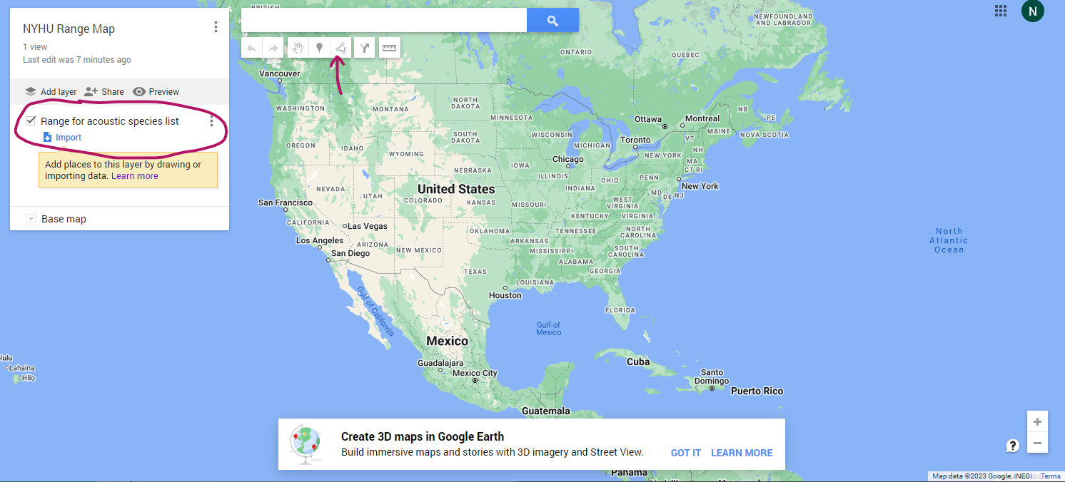
- Once you close your shape, a box will pop up for you to name the polygon. Name it either the species code and your initials (e.g., PAHE) or an area that the species should be excluded from the list (e.g., Exclude PAHE). In the description box, add your name. If you make a mistake, click on the created polygon and select the trashcan icon to delete.
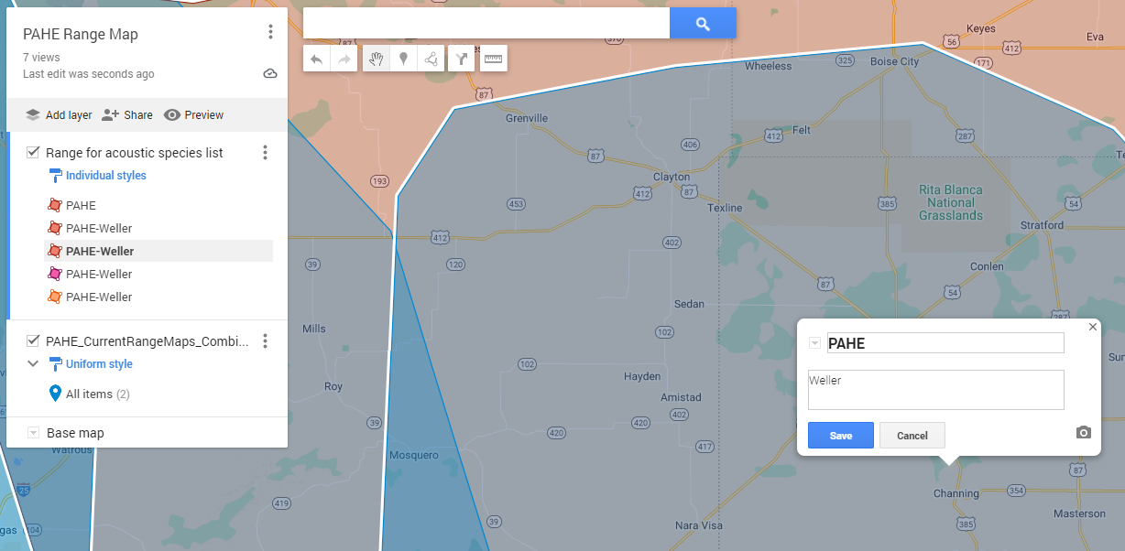
- Once you have a feature added to the map, click on the paint roller, and select the option to style by name. This will group all polygons with the same name together.
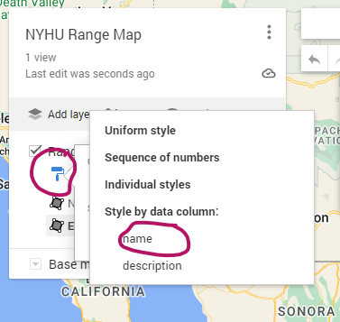

- If you want to export the layer for some reason, click on the 3 dots to the right of the layer name
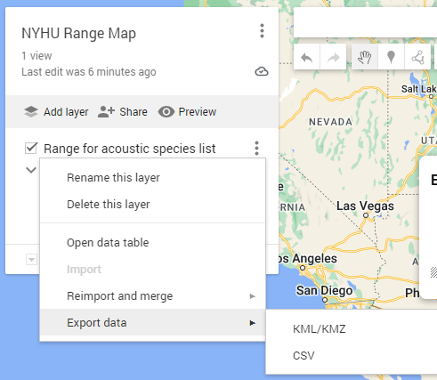
- If you want to import another layer to the map for reference, select add layer then click on import and add your file. Added files must be under 5 mb and in CSV, XLSX, KML, or GPX format.

